TASK:1

## Installation VMware on desktop

### Downloading VMware virtual machine:

1. Open your internet browser and search “**VMware Virtual machine download**”.
2. Click on first link , as shown below.

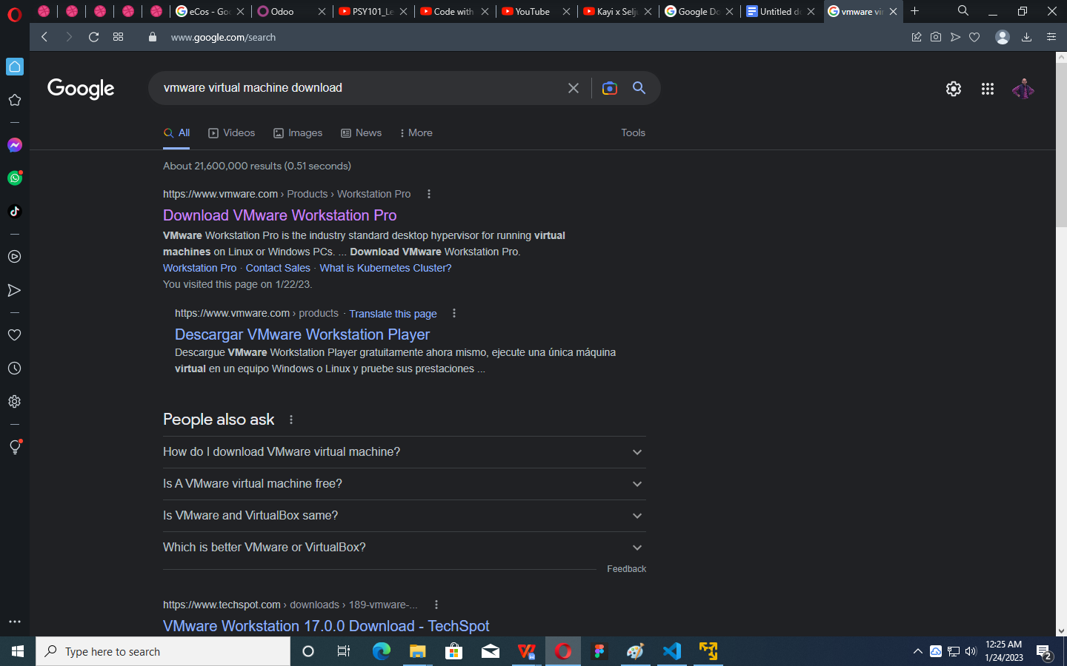

1. Scroll down the page and click on “**Download Now**” in section of windows

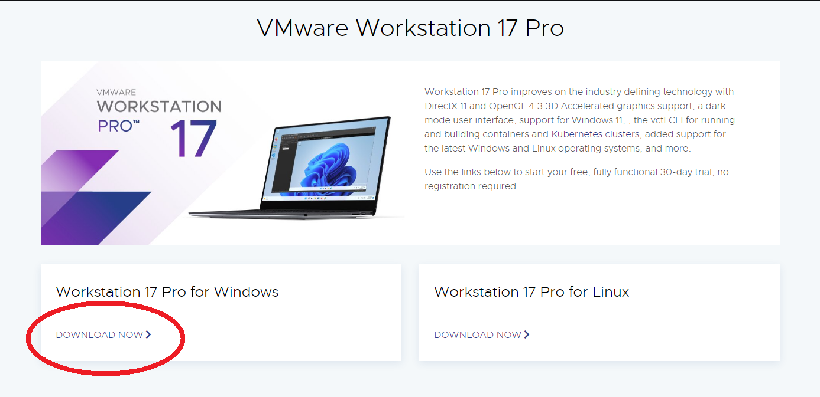

1. A setup will start downloading

### Installing VMware virtual machine:

1. Go to the download folder and double click to run the setup.

###### Error: Popup menu saying “Unsupported CPU detected”

**Solution:** Click on “Ignore”

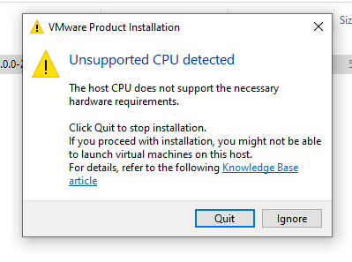

1. It will ask you to restart the computer. Click “**Yes**”.
2. Once your system is restarted, open the setup folder and double click to run it.

###### Error: Popup menu saying “Unsupported CPU detected” again.

**Solution:** Click on “Ignore”



1. After Setup is start click **Next**
2. Click on **checkbox** to tick the box and then click on **Next.**

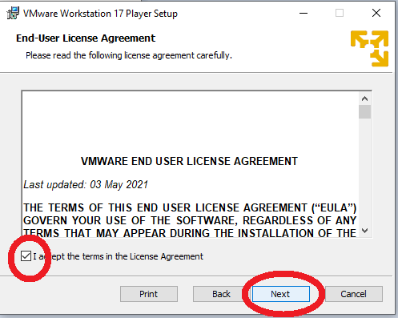

1. Once the installation is complete, click on **Finsh.**

## Installing Ubuntu through VMware virtual machine

### Download Ubuntu ISO:

Open your browser and search “**Ubuntu download**” and click on first link, as shown below.

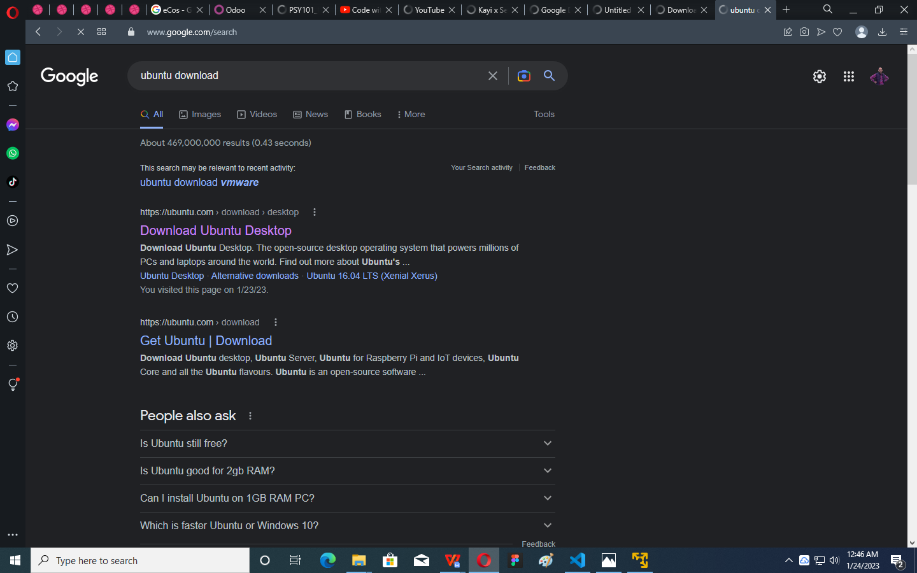

Scroll down and click on “Download” button. Setup will be start downloading.

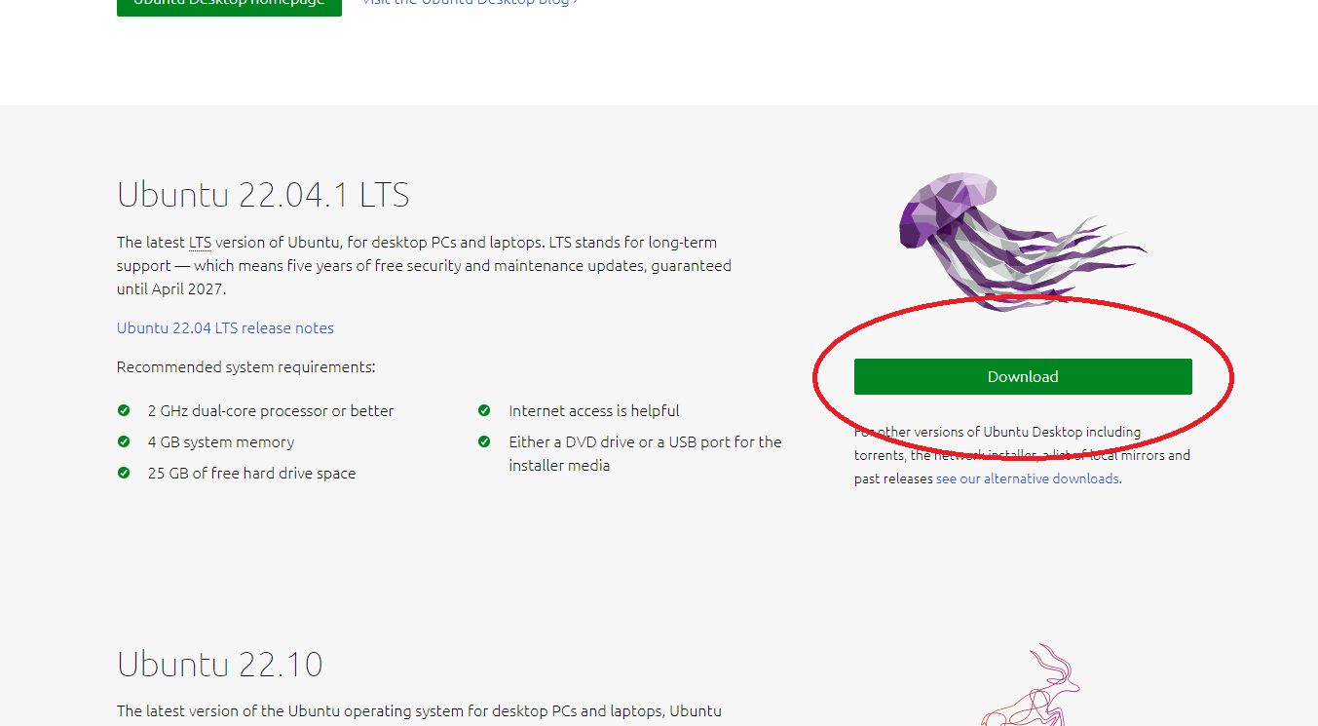

###### Error: No downloading start after clicking on “Download”.

Solution: Click on “download now”as shown in pic bellow. Your downloading will be start

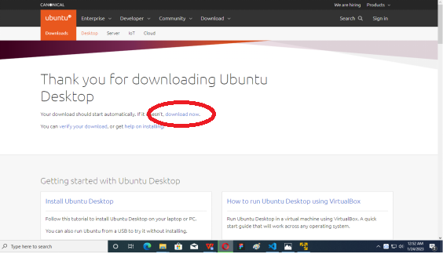

### Installing Ubuntu through VMware virtual machine

1. Search “**VMware Workstation”** in search bar of windows and run **“VMware Workstation”** by double clicking on its icon.
2. Click "Continue".

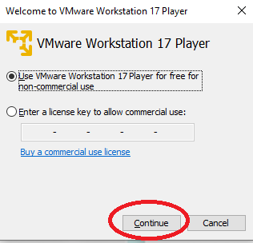

1. Click on “**Create a New Virtual Machine**”.

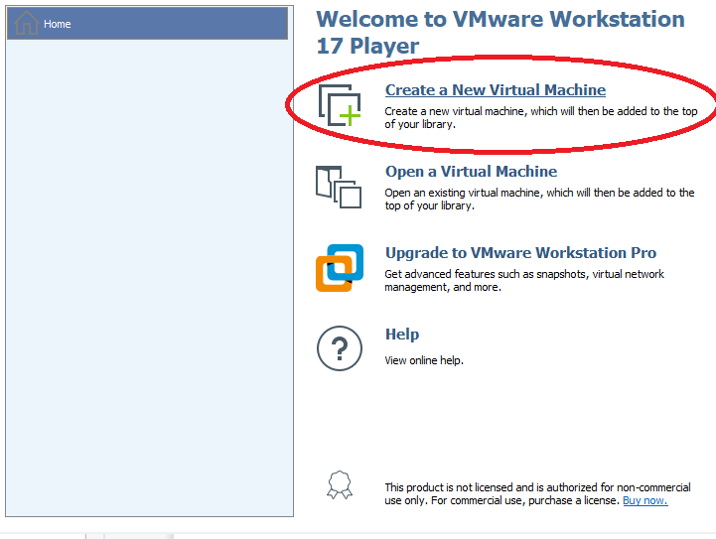

1. Browse ISO file where it is installed and selected it and click “**Next**”

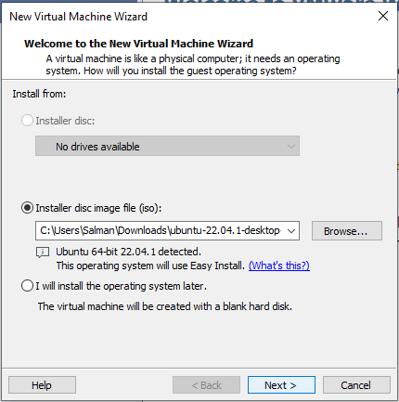

1. Enter your details, make sure “username” you enter is all small alphabets with no space.

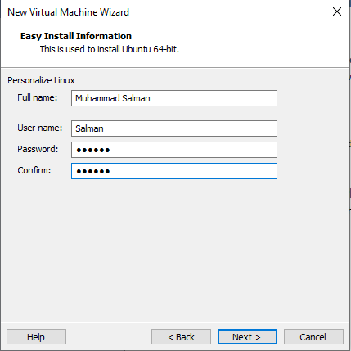

1. Type machine name you want to set and Browser location for installation of **Ubuntu** and make sure you have enough **20Gb** to install it.

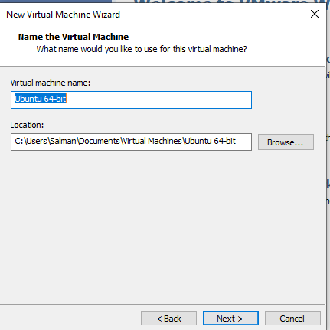

1. Click on “**Customize Hardware**” if you want to change, otherwise it will set half of your system specifications.

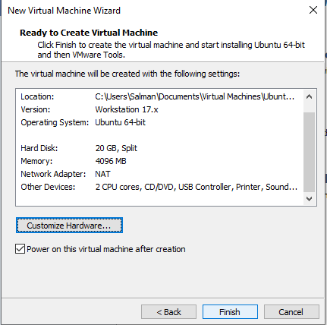

1. Click **Finish.**

**Error: Popup menu saying Error while powering on … Failed to start the virtual machine.**

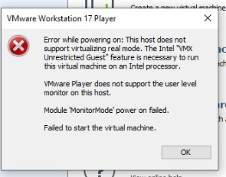

**Solution:** Follow all the below steps to solve this error.

1. Restart your system and enter **BIOS,** inside it find **Virtual Technology** enable it.
2. Search **VMware Workstation.** Right click on its **VMware Workstation** icon and click **Open file location.** as shown bellow

.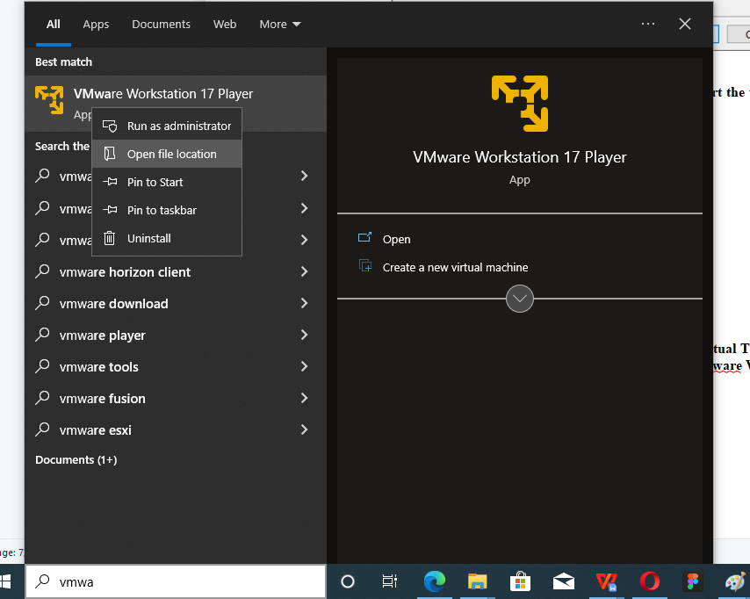

1. Open “**VMware Workstation**” folder and open “**config**” file using **VScode**
2. At the end insert following line and save it

**monitor.allowLegacyCPU = "true"**

1. A popup menu will appear saying **“Failed to save”** click on **“Retry as admin”.** File will be save.
2. Error is resolved now again search “**VMware Workstation**” and run it.

### Setup Installation Ubuntu for the first Time

1. Once the Ubuntu machine is run you have to wait until setup is start installing. When installation is start following screen will be shown. Click **Continue.**

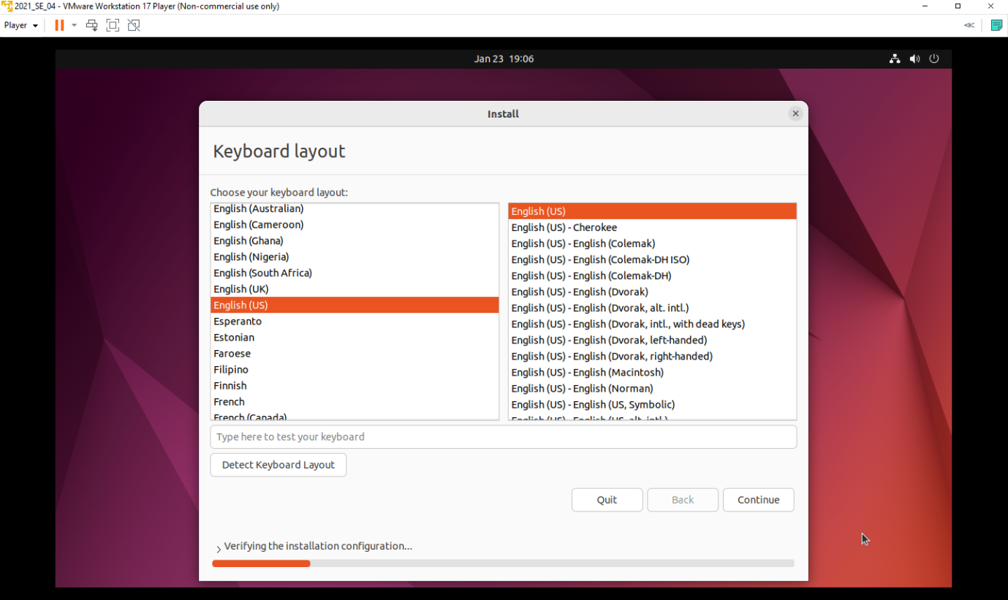

1. Press **Continue** again.

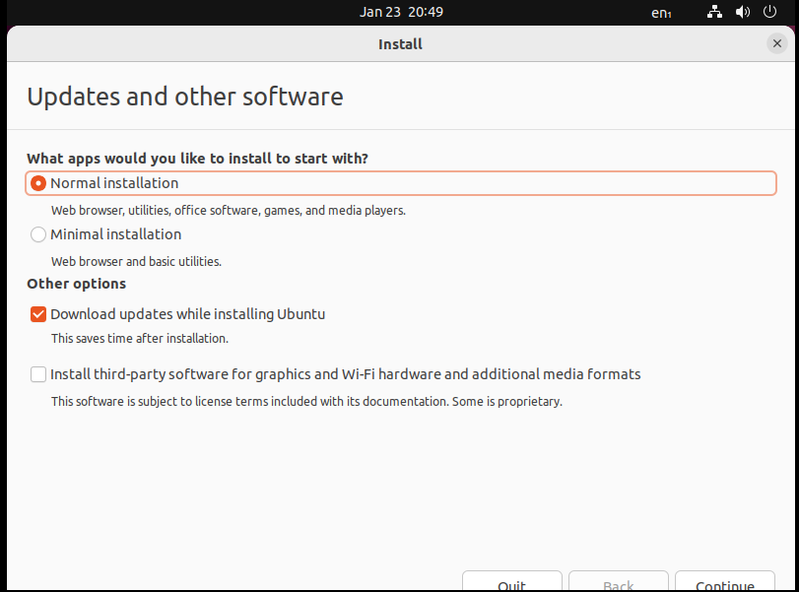

1. Press **Install Now.**

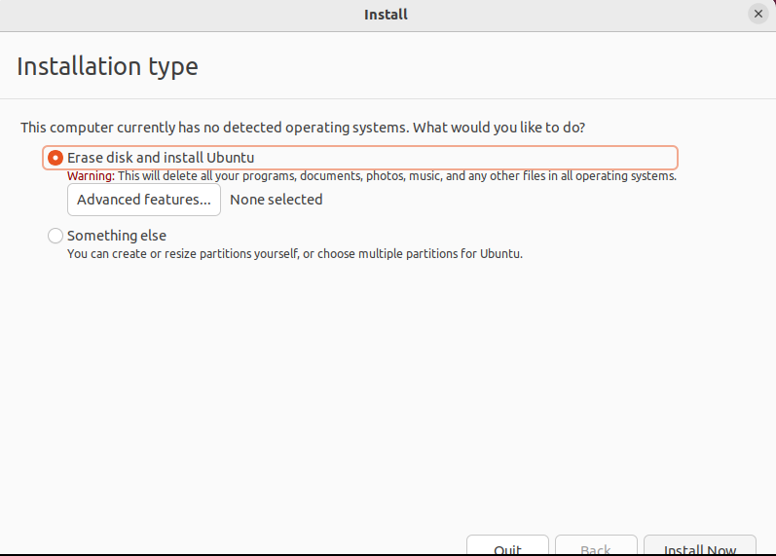

1. Search your **City,** select it and **Continue.**
2. Enter your credentials in following fields and click on **Continue.**

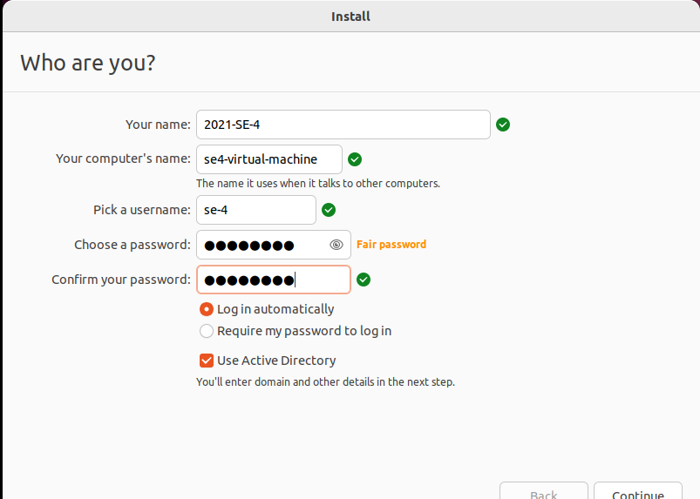

1. Enter domain details and click on **Cotinue**

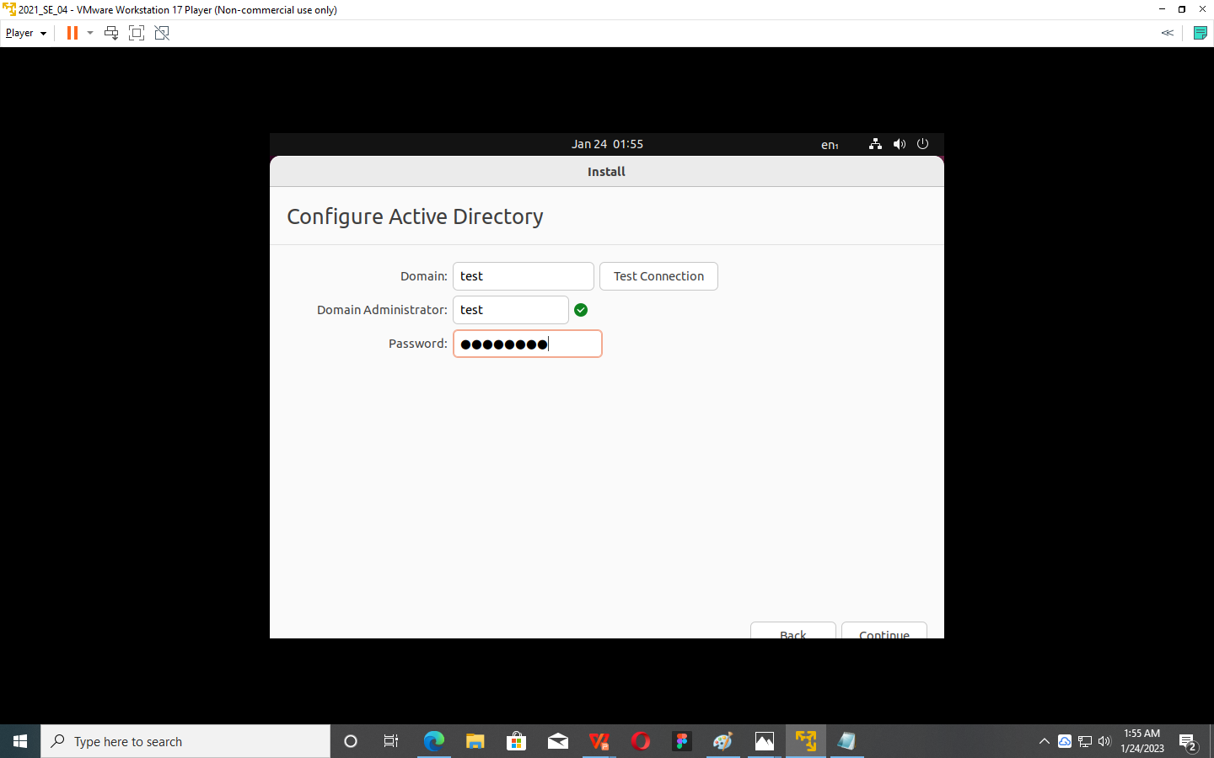

1. Wait until installation is complete. Once the installation is completed, it will ask you to restart,so Click on “**Restart Now**”

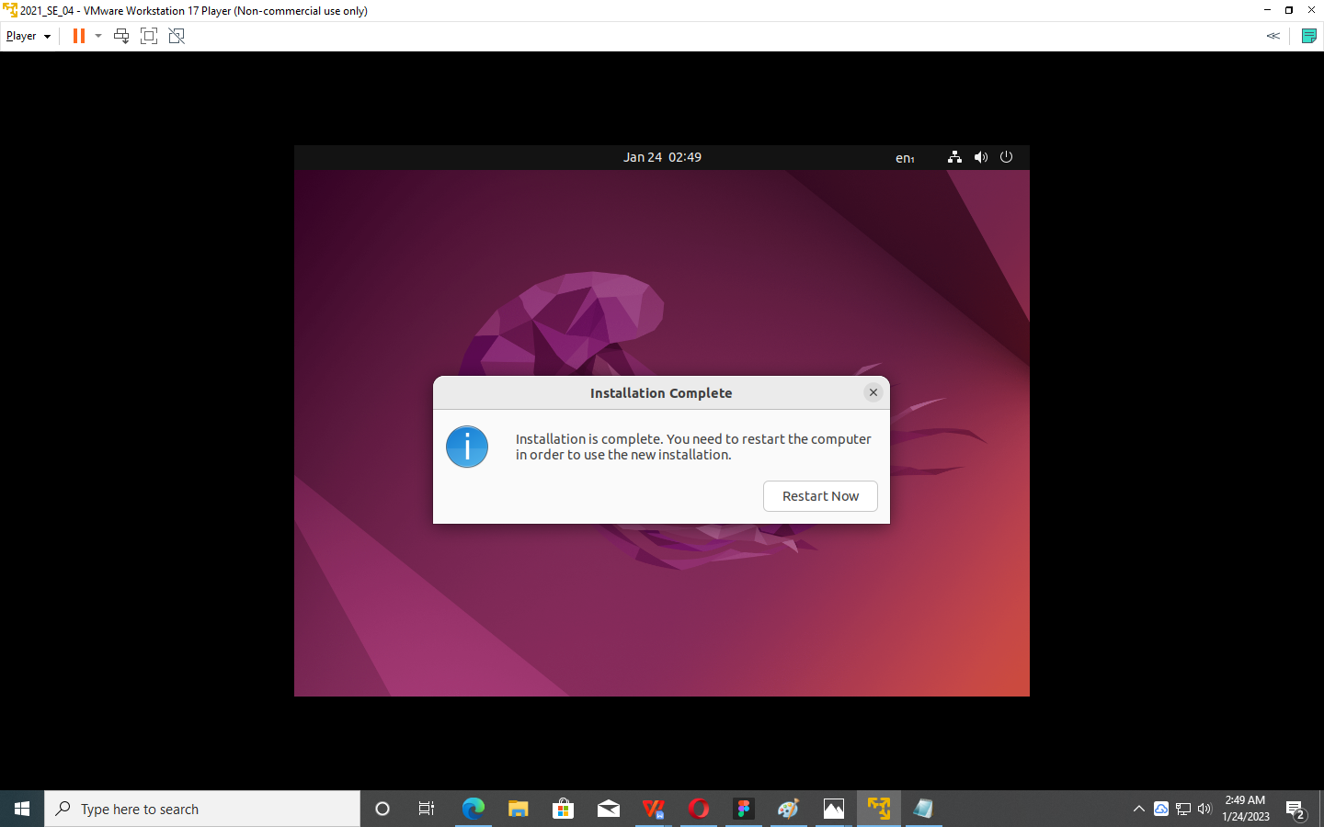

1. Setup is successfully installed.

Task:2

### Install Compiler of C++ & C

1. Click on **“Show Applications”** icon that is present at bottom left corner.
2. Click on **“Terminal”** icon
3. To install compiler type ( C and C++ ):
   1. For C language: gcc

Command: **sudo apt-get install gcc**

* 1. For C++ Language: g++

Command: **sudo apt-get install g++**

1. Enter your password. Your password will not be visible so just type it and press enter

Error:

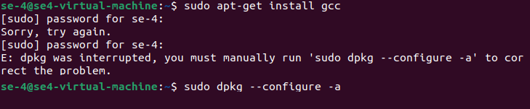

**Solution:**    
 

1. Type command :  **sudo dpkg --configure a** and press enter
2. Wait until terminal ask you to type a command. Then do **Step 3** compiler will be start installing.
3. Press two times “**y**” key to install the compiler.
4. Compiler is installed successfully.
5. Create a folder name “**Lab1**” by following command   
    **mkdir lab1**